**Machine Learning-Assisted Twisted Bilayer MoS₂ HER Performance Research: A 5-Month Project Plan**

**Abstract**

This research project presents a focused 5-month plan to develop machine learning-assisted characterization tools for twisted bilayer MoS₂ and establish quantitative correlations with hydrogen evolution reaction (HER) catalytic performance. By leveraging recent advances in automated 2D materials characterization and deep learning, this project will create an end-to-end pipeline from optical microscopy image analysis to electrochemical performance prediction. The compressed timeline focuses on rapid prototyping and validation, targeting key HER performance metrics including Tafel slopes, overpotential, and current density as functions of twist angle.

**1. Project Overview**

**1.1 Research Objectives**

The primary goal is to establish a comprehensive ML-assisted workflow for correlating twist angles in bilayer MoS₂ with HER catalytic performance. Specific objectives include:

* **Automated Characterization**: Develop robust computer vision algorithms for identifying and measuring twist angles in bilayer MoS₂ from 100X optical microscopy images
* **Performance Correlation**: Establish quantitative relationships between twist angles (0° to 120°) and HER performance metrics
* **High-Throughput Screening**: Enable rapid analysis of thousands of flakes per substrate to identify optimal twist angle ranges
* **Open-Source Tools**: Create accessible software tools for the 2D materials research community

**1.2 Project Timeline Overview**

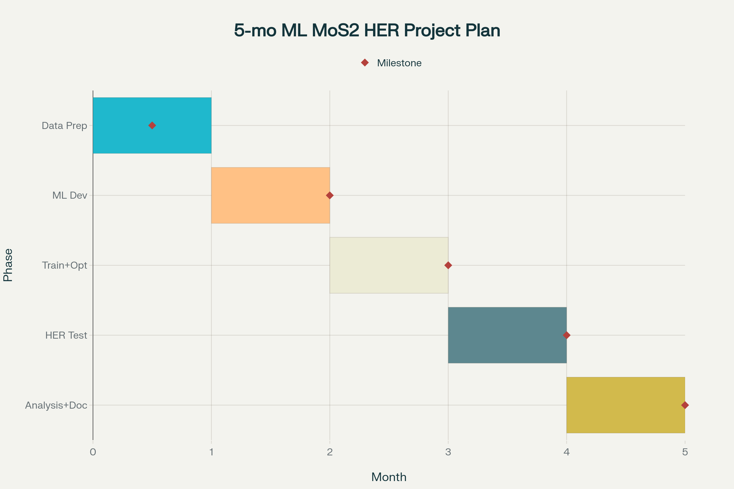

5-Month ML-Assisted Twisted Bilayer MoS₂ HER Research Project Timeline

This compressed 5-month timeline maximizes efficiency by leveraging existing tools and focusing on essential deliverables. Each month has specific goals and measurable outcomes to ensure rapid progress toward the final objectives.

**2. Technical Approach**

**2.1 ML-Assisted Characterization Pipeline**

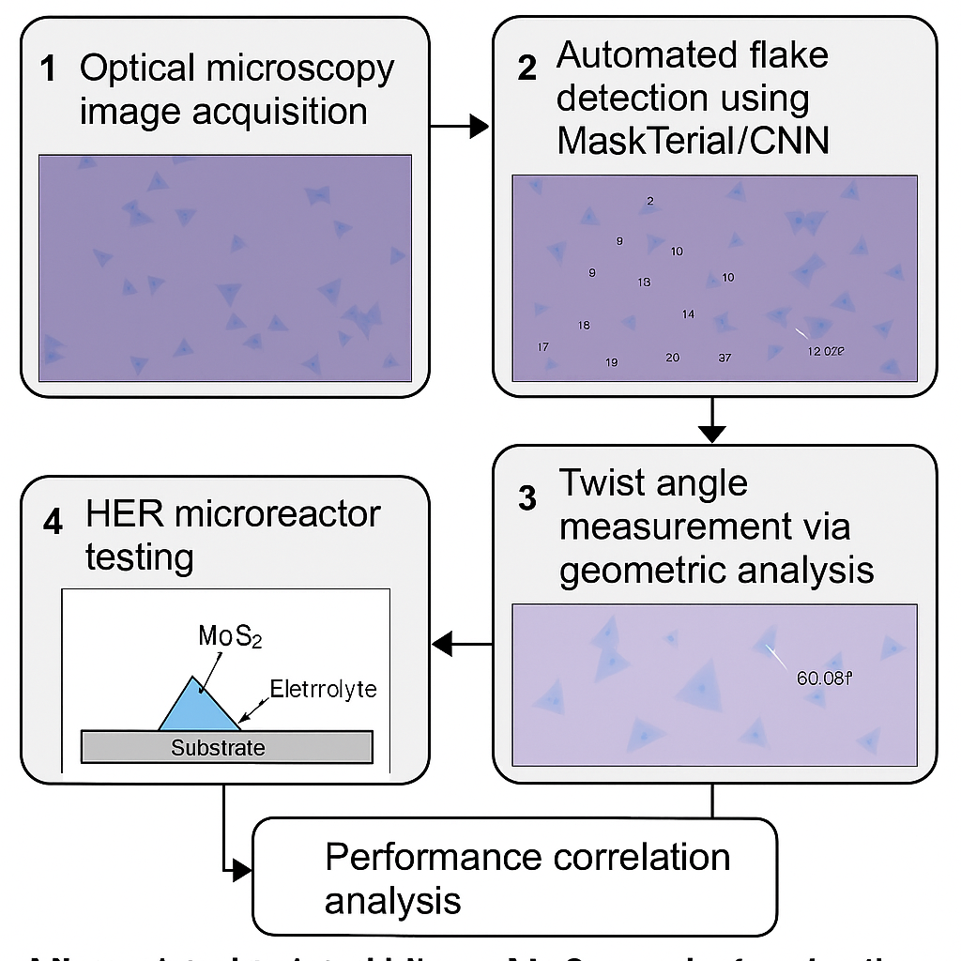

ML-assisted workflow for twisted bilayer MoS₂ characterization and HER performance analysis

The technical approach integrates multiple established methodologies into a streamlined workflow optimized for the 5-month timeline:

**Image Acquisition and Processing**: Utilize 100X optical microscopy for consistent image capture, implementing standardized imaging protocols to ensure reproducible data collection across all samples.

**Automated Flake Detection**: Leverage the recently released MaskTerial foundation model, which requires only 5-10 training images for adaptation to new materials, significantly reducing initial setup time.

**Twist Angle Measurement**: Implement CNN regression models trained on synthetic datasets, following successful approaches that achieved >95% accuracy with datasets containing 10,000+ synthetic images.

**HER Performance Testing**: Fabricate microreactors for rapid electrochemical characterization, enabling high-throughput correlation of structural and catalytic properties.

**2.2 Key Performance Metrics**

The project will focus on establishing correlations between twist angles and critical HER performance indicators:

* **Tafel Slope**: Target identification of twist angles yielding slopes comparable to or better than Pt (≤30 mV/dec)
* **Overpotential**: Measure overpotential at 10 mA/cm² current density across different twist angles
* **Exchange Current Density**: Quantify intrinsic activity as a function of twist angle
* **Long-term Stability**: Assess durability of optimal twisted bilayer structures

**3. Detailed 5-Month Implementation Plan**

**Month 1: Data Collection and Preparation**

**Weeks 1-2: Sample Preparation and Imaging**

* Implement standardized optical microscopy protocols
* Collect 200-300 high-quality images of twisted bilayer MoS₂ samples
* Establish consistent illumination and contrast conditions

**Weeks 3-4: Manual Labeling and Validation**

* Manually label 50-100 high-confidence twisted bilayer regions using ImageJ/Fiji
* Implement multiple-annotator consensus for accuracy validation
* Create ground truth dataset using complementary characterization methods

**Key Deliverable**: Validated training dataset with accurate twist angle measurements

**Month 2: ML Model Development**

**Weeks 1-2: Architecture Design and Implementation**

* Adapt MaskTerial foundation model for bilayer MoS₂ detection
* Implement CNN regression architecture for twist angle prediction
* Generate synthetic training data using geometric models

**Weeks 3-4: Initial Training and Validation**

* Train detection models using transfer learning approaches
* Validate performance against manual annotations
* Optimize hyperparameters for accuracy and processing speed

**Key Deliverable**: Functional ML pipeline achieving >85% accuracy in flake detection

**Month 3: Model Optimization and Scaling**

**Weeks 1-2: Performance Enhancement**

* Implement advanced data augmentation techniques
* Fine-tune models using active learning approaches
* Optimize processing pipeline for batch analysis

**Weeks 3-4: Large-Scale Validation**

* Process entire substrates containing thousands of flakes
* Generate statistical distributions of twist angles and morphologies
* Achieve target accuracy of >90% for twist angle measurement

**Key Deliverable**: Optimized ML pipeline capable of processing >1000 flakes per hour

**Month 4: HER Performance Characterization**

**Weeks 1-2: Microreactor Fabrication**

* Design and fabricate microreactor arrays for parallel HER testing
* Implement automated electrochemical measurement protocols
* Establish standardized testing conditions

**Weeks 3-4: Electrochemical Measurements**

* Conduct comprehensive HER testing across identified twist angle ranges
* Measure Tafel slopes, overpotentials, and exchange current densities
* Generate performance maps correlating structure with activity

**Key Deliverable**: Comprehensive dataset of HER performance vs. twist angle relationships

**Month 5: Analysis and Documentation**

**Weeks 1-2: Statistical Analysis and Correlation**

* Perform rigorous statistical analysis of structure-property relationships
* Identify optimal twist angle ranges for HER catalysis
* Compare performance metrics with Pt benchmarks

**Weeks 3-4: Documentation and Dissemination**

* Prepare comprehensive manuscript for high-impact journal submission
* Create open-source software package with user documentation
* Generate presentation materials for conference dissemination

**Key Deliverable**: Manuscript submission and open-source tool release

**4. Resource Requirements and Infrastructure**

**4.1 Equipment and Materials**

**Existing Infrastructure**:

* 100X optical microscopy capability
* CVD synthesis equipment for twisted bilayer MoS₂ production
* Basic electrochemical characterization setup

**Additional Requirements**:

* GPU-enabled workstation for ML model training (8GB+ VRAM)
* Microreactor fabrication materials and equipment
* High-resolution imaging camera for consistent data collection

**4.2 Software and Computational Tools**

**Open-Source Foundations**:

* MaskTerial foundation model for 2D materials detection
* OpenCV for image processing and geometric analysis
* PyTorch/TensorFlow for deep learning implementation
* Automated flake search tools from research institutions

**Custom Development**:

* Twist angle regression models adapted for MoS₂ morphologies
* Batch processing pipelines for substrate-scale analysis
* Electrochemical data integration and correlation algorithms

**5. Risk Mitigation and Contingency Plans**

**5.1 Technical Risks and Solutions**

**Limited Training Data**: If manual labeling proves insufficient, implement semi-supervised learning approaches and expand synthetic data generation capabilities.

**Model Performance Issues**: Maintain fallback to OpenCV-based geometric analysis methods, which have demonstrated effectiveness in recent literature.

**HER Testing Delays**: Prioritize high-confidence twist angle candidates identified through ML screening to maximize testing efficiency within timeline constraints.

**5.2 Timeline Contingencies**

**Months 1-3 Buffer**: Build 1-week buffer into data collection and model development phases to accommodate unexpected delays.

**Parallel Processing**: Design microreactor fabrication (Month 4) to occur in parallel with final model optimization to maximize efficiency.

**Minimum Viable Product**: Define core deliverables that can be completed even if some advanced features are deferred to future work.

**6. Expected Outcomes and Impact**

**6.1 Scientific Contributions**

**Structure-Property Relationships**: Establish quantitative correlations between twist angles and HER performance, advancing fundamental understanding of twistronics in catalysis.

**Methodology Development**: Create validated protocols for ML-assisted characterization that can be extended to other 2D material systems.

**Performance Benchmarking**: Identify twist angle ranges that achieve HER performance comparable to or exceeding current benchmarks.

**6.2 Technological Impact**

**High-Throughput Screening**: Enable analysis of >30,000 structures per substrate, dramatically accelerating materials discovery workflows.

**Automated Characterization**: Reduce manual analysis time by >85% compared to conventional methods, as demonstrated in similar high-throughput applications.

**Open-Source Tools**: Provide community-accessible software that democratizes advanced characterization capabilities.

**6.3 Publication Strategy**

**Primary Manuscript**: Target high-impact journals (Nature Communications, Advanced Materials, or Nano Letters) focusing on the integrated ML-HER correlation approach.

**Community Engagement**: Present results at major conferences (MRS, ACS) and contribute to open-science initiatives through software and data sharing.

**Follow-up Studies**: Establish foundation for extended research into other twisted 2D material systems and catalytic applications.

**7. Budget Considerations**

**7.1 Personnel and Equipment**

The compressed 5-month timeline requires focused resource allocation:

* **Computational Resources**: GPU workstation and cloud computing for intensive training phases
* **Materials**: Microreactor fabrication supplies and electrochemical testing consumables
* **Characterization**: Additional imaging and validation equipment as needed

**7.2 Cost Optimization Strategies**

**Leverage Existing Infrastructure**: Utilize established CVD synthesis and basic characterization capabilities to minimize new equipment costs.

**Open-Source Tools**: Build upon freely available ML frameworks and 2D materials analysis tools to reduce software licensing costs.

**Collaborative Resources**: Partner with French ML expertise and utilize shared computational resources when possible.

**8. Success Metrics and Evaluation**

**8.1 Technical Milestones**

**Month 1**: Validated training dataset with >50 accurately labeled samples  
**Month 2**: ML pipeline achieving >85% accuracy in flake detection  
**Month 3**: Optimized system processing >1000 flakes per hour with >90% accuracy  
**Month 4**: Complete HER performance dataset across representative twist angle ranges  
**Month 5**: Manuscript submission and open-source software release

**8.2 Performance Benchmarks**

**Accuracy Targets**: >90% precision in twist angle measurement (±5° tolerance)  
**Throughput Goals**: Process entire cm²-scale substrates within 2-4 hours  
**HER Performance**: Identify twist angles achieving Tafel slopes <50 mV/dec  
**Community Impact**: Open-source tool adoption by >5 research groups within 6 months

**Conclusion**

This focused 5-month project plan leverages recent advances in ML-assisted materials characterization to establish quantitative structure-property relationships for twisted bilayer MoS₂ HER catalysts. By concentrating on essential deliverables and utilizing established methodologies, the project can achieve significant scientific impact within the compressed timeline while creating valuable tools for the broader research community. The emphasis on automation and high-throughput analysis addresses critical bottlenecks in 2D materials research, potentially accelerating the discovery of optimal twisted bilayer structures for hydrogen production applications.

⁂